(Approx. 722 words)

Working with Apps on Windows 10
By Rosita Herrick, Windows Corner, Sarasota Technology Users Group
December 2018 issue, STUG Monitor
www.thestug.org
hrosita (at) aol.com

Frequently, either when I am teaching or when I prepare one of the Windows 10 Corner articles, I use a few apps that are distributed with the operating system and are available to any user. At that time, I am always asked how to start these apps. In this last article for 2017, I decided to describe these apps, in addition to some keyboard shortcut keys and right click options that enable me to navigate the operating system faster and easier.

1. To start the Magnifier, just enter the name in the Cortana search box.
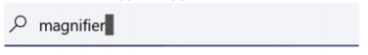

At the top of the display, a link shows up. By clicking on it, the app is started.
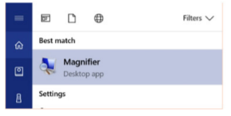

Another option is to quickly open the Magnifier by using the keyboard shortcut, Windows key with the plus sign (+), to zoom in and Windows key with minus sign (-) to zoom out. Use Windows key and Esc to exit the magnifier. You can use the Magnifier knowing just these three shortcuts, but there are actually a few more options.

When the magnifier starts, a small box is being displayed where you can change some options. One problem is that sometimes it disappears before you can select additional options. If that happens, close the magnifier by pressing the Windows key and the Escape key and restart it.

Clicking on the Views caret displays the magnification option.
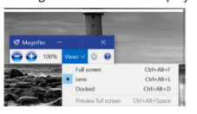

I usually keep the Lens option selected so that I can move the area magnified with the mouse.

2. The next app I use is the Sticky Notes.

I believe most of us have used a sticky note to remind us of something we need to do, something to buy or just something like a specific keyboard shortcut and/or a reminder to call a friend.

Again, to start Sticky Notes, just type the name of the app in the search box. And then click on the displayed link.

Once Sticky notes is started, a blank square shows on the screen. There are very few options to this simple app.
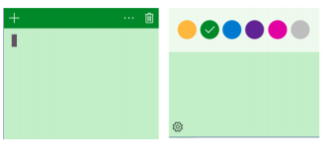

Clicking on the 3 dots displays the option to change the color of the note. As you can see, green is selected. In the first insert, there is a cursor. You can type any comment you want on the note. It stays on your desk until you click on the trash icon to delete it. Also, clicking on the + sign will display another note. The notes can be stacked next to each other either vertically or horizontally.
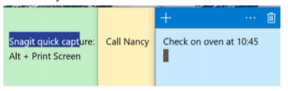

3. Last, but not least, is the Snipping Tool. Again, enter Snipping tool in the search box. The link displayed looks like this:
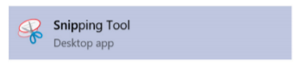
And the starting windows looks like this:
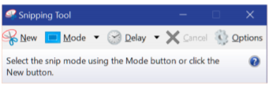
The snip mode can be Free-form, rectangular (shown as a square), Window snip and Full-screen snip. Clicking on the Options icons shows different ways the snipped area can be treated, and, for touch screens, there is a box where the user can select the color of the snip border. To start the snip, click on the New icon. The screen will become less sharp and a cross will appear where the mouse cursor was, and the user can just frame the area to extract.

Here is the result of snipping the tool’s display:
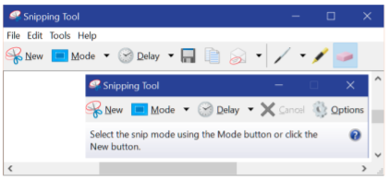

Check the File, Edit, Tools and Help tab to work with this app. By the way, you can make notes on the snip by using the pen or highlighter icon, and if you don’t like the result, you can erase it by using the eraser.

Here are the YouTube URL’s for these three apps.

Snipping Tool: https://www.youtube.com/watch?v=jRu2exEPFiI
Magnifier: https://www.youtube.com/watch?v=GFNPyen9urw
Sticky Notes: https://www.youtube.com/watch?v=yvNsNh1QXbg

Now to the keyboard shortcut keys: A right click on the Windows icon in the lower left corner of the status bar will bring up a list of links to system options, such as starting the Task Manager, Command prompt, Shutdown or Sign up.

Win+E will start the File Explorer.
Win+P will display project options
Win+D will display the Desktop (without closing active apps)
Win+L will display the logon screen (I use this one when I must leave the computer in a common area).

I hope these writings make your use of Windows 10 more enjoyable.

